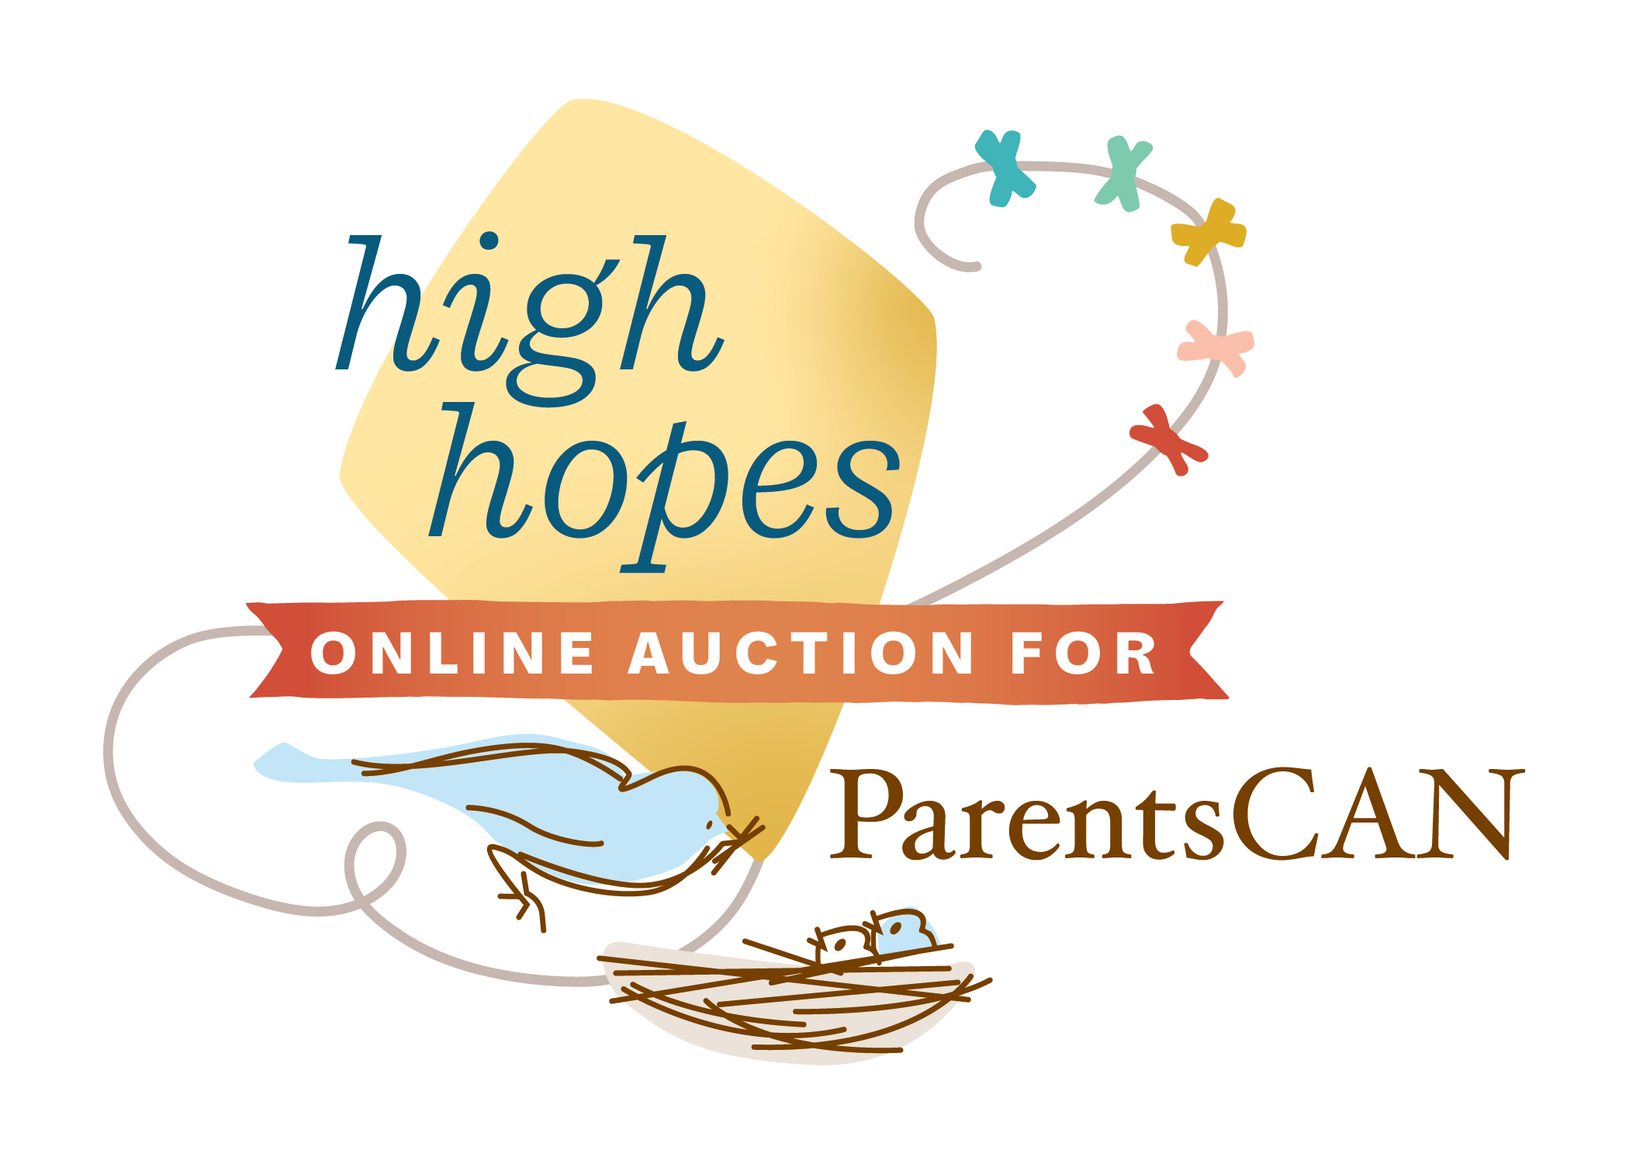

2025 ParentsCAN

High Hopes Online

Auction Donation Form

Donor/Business Name:  (as it should appear in the program) | Donor Address:
Contact Name:  Contact Phone:  Contact Email: | Mailing address:  (if different from above)
Auction Item  (Please include description of item or package as it should appear in the program and promotional information. Please be clear on any expiration or restriction information.) | Please complete for donations of wine:  Name:  Vintage:  Varietal:  Size of bottle:
Value: $__________________
Retail value (fair market value) of item or package. Please approximate if necessary.
We will deliver/mail the auction item or certificate by:_______________________________
Please arrange to pick up the item on/after _______________________________________
Person to contact for pick up: __________________________________________________
Phone: ________________________________ Email: _______________________________
Please create a certificate for me.

Thank You! Your donation may be tax deductible. Please check with your tax advisor.
I am interested in receiving an invitation to the event.
I cannot provide an auction item, please accept my donation of $_____________________dkdk

We appreciate your participation and your support of ParentsCAN, a 501(c)(3) public benefit organization, Tax ID# 56-2498308.
Please return form by Friday May 7, 2024. Forms may be mailed, faxed or emailed to:
ParentsCAN, 433 Soscol Ave., #B-160, Napa, CA 94559 Phone: 707.253.7444 Fax: 707.253.2244
Email: chrisr@parentscan.org

